APES Review Worksheet #2
- List three consequences of global warming.
1)
2)
3)
- List three things you could do to decrease your contribution to global warming.
1)
2)
3)
- List four greenhouse gases.
Altitude
(km)
Temperature (°C)
1) 3)
2) 4)
- The molecular formula of ozone is ________.
- Use the axes to the right for the following:
  - Draw a line representing the Earth’s atmosphere.
  - Label each layer of the Earth’s atmosphere and identify where the greenhouse effect occurs and the ozone layer is situated.
- The chemicals that deplete the ozone layer are __________.
- In the box below, write out a series of chemical equations that illustrate the destruction of the ozone in the ozone layer.
- Provide examples of three biotic components of an ecosystem.
1) 2) 3)
- Provide examples of three abiotic components of an ecosystem.
1) 2) 3)
- Complete the following table:
Trait | Carbon | Nitrogen | Phosphorus | Water
importance to life
largest reservoir
method of transport
cycle length (long/short)
- Write the balanced chemical equation for photosynthesis in the box on the right.
Photosynthesis:
- The approximate age of the Earth is _______________ years.
- Write the balanced chemical equation for cellular respiration in the box on the right.
Cellular Respiration:
- Match the following:
  - generalist species Zebra mussel
  - specialist species Galapagos tortoise
  - invasive species American Alligator
  - keystone species Tiger salamander
  - indicator species Norway rat
  - endemic Species Giant Panda
- Define the term biodiversity.

- Humans have engaged in agriculture for approximately ____________ years.
- Define biome

- A man-made product is also known as __________________.
- Sketch and/or label the following on the map of the world below:
  - the equator
  - the tropic of Cancer and the tropic of Capricorn
  - the Mid-Atlantic Ridge
  - the location of suppressed upwelling characteristic of the occurrence of El Niño
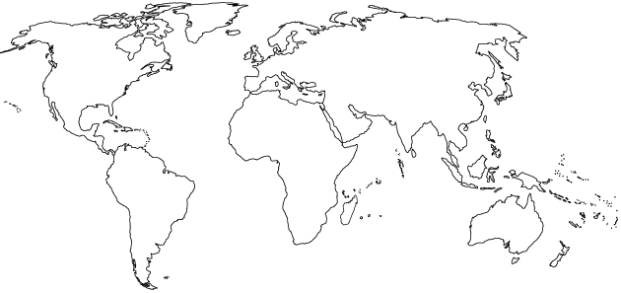
  - the location of Diamond Bar, China, India, Ethiopia, Brazil, and Bangladesh
- Complete the following table:
Type of Biome | Typical Location | Typical Climate | Adaptations for survival
Tropical Rain Forest
Temperate Deciduous Forest
Taiga (Boreal) Forest
Tropical Grasslands (Savanna)
Temperate Grassland (Prairie)
Tundra (cold grassland)
Desert
- Describe the circumstances that will result in cultural eutrophication.

- Explain how increasing the concentration of carbon dioxide in the atmosphere leads to ocean acidification.

