APES Review Worksheet #4
- Completely label the following diagram of a sewage treatment plant and list the items removed at each step.

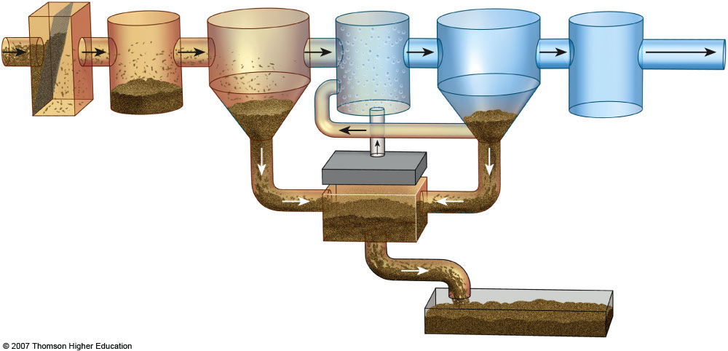

- In the box to the right, list the ranks of coal in order from highest to lowest energy content. (indicate the direction in the box.)
- List three air pollutants that are emitted during the burning of coal.
1) 2) 3)
- List 7 products that are derived primarily from crude oil:

- The acronym OPEC refers to the _____________ of _____________ _____________ _____________ and it is important because:

- Fracking is short for ______________ ______________ and it is a concern because…

- Explain what the Deepwater Horizon was, where it went, and why it is significant.

- The acronym ANWR refers to the _____________ _____________ _____________ _____________ and it is important because:

- Perform the following calculations: (Show all of your work in a logical progression to the final answer.)
  - A family has a total of 1500 Watts of light bulbs throughout their house, if they replace them all with LED light bulbs, which use 90% less energy, the family will now use _____________ Watts of electricity.
Show work:

  - A space heater operates at 1500 Watts, if it is used for 10 hours each day for one week and the cost of electricity is 20 cents per kilowatt-hour, it will cost _____________ to operate the heater for the week.
Show work:

- The acronym CAFE refers to the _____________ _____________ _____________ _____________ and it is important because:

- List four things you could do to conserve energy.
1)
2)
3)
4)
- State where Chernobyl is located and explain what happened there.

- Complete the following chart.
Mining Technique | Description | Environmental consequences
Open-Pit mining
Subsurface mining
Strip mining
Mountaintop removal
Drilling
- Strengthen this weak statement: “Mining causes pollution that may disrupt the environment.”

- Match each of the following elements with its ore:
  - aluminum galena
  - iron quartz
  - uranium bauxite
  - lead hematite
  - silicon pitchblende
- Explain what happened at Three Mile Island, and why it is significant.

- Explain how thermal pollution is produced by power plants.

- Explain what happened at Fukushima Daiichi and why it is significant.

- Perform the following calculation. Show all of your work. A radioactive cloud may contain Iodine-131, which has a half-life of 8 days. If the waste must decay to a concentration of less than 0.1% to be considered safe, it will take approximately ______ days to reach safe levels.
Show work:

- List three species that may be threatened by the construction of a solar power tower in the California Desert.
1)
2)
3)
- _______________ is the active element in most photovoltaic cells.
- Perform the following calculation. (Show all of your work in a logical progression to the final answer.) A family has a 75 m² solar array on their house, which has an efficiency of 10%. If the average insolation on their array is 6 kWh/m²/day and their average cost of electricity is 20 cents per kilowatt-hour, the family has the capacity to produce _________ worth of electricity every day, and _________ every year, from the sun.
Show work:

