APES Review Worksheet #5
- Name the following:
NO NO₂
NO₂⁻ NO₃⁻
NO₂ N₂O
N₂ NH₃
NH₄⁺ HNO₃
NO_{x}
- In the box to the right, sketch a house and the surroundings of a house that is designed to make the greatest use of passive solar energy in the northern hemisphere. Include, inside the box, the location of both the winter and summer sun, and labels to indicate the compass direction that the house faces.
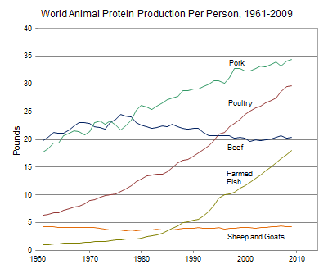
- Use the information in the diagram on the left, to answer the following:
  - The percent change in the per capita global production of protein from poultry between 1980 and 2000 was approximately ________.
  - The percent change in the per capita global production of protein from farmed fish between 1980 and 2000 was approximately ________.
  - The percent change in the per capita global production of protein from beef between 1961 and 2009 was approximately ________.
- The founder of the Sierra Club was ________ ________.
- Rachel Carson wrote the book ________ Spring to raise people’s awareness of the harmful effects of the pesticide ________.
- The acronym ENSO refers to _____________ _____________ _____________ _____________, which occurs in the _____________ ocean.
- Place the following 8 events in chronological order: the oil spill of the Exxon Valdez; the meltdown of the reactor at Chernobyl; the discovery of contamination at Love Canal; The first Earth Day; the leak of methyl isocyanate in Bhopal; the drafting of the Kyoto Protocol; the ratification of the Montreal Protocol, passage of the US Endangered Species Act
1) 5)
2) 6)
3) 7)
4) 8)
- Strengthen this weak statement: “Fossil fuel use releases carbon dioxide, which causes the greenhouse effect.”

- The acronym BOD refers to _____________ _____________ _____________, which is:

- Perform the following calculation. Show all of your work. If the grasses on a 100-hectare area of grassland grow at an average rate of 1 cm/day, the average volume of grass that is added to the grassland each day is ____________ m³. If the density of the grasses that grow in the grassland averages 400 kg/m³, the net primary productivity is approximately _____________ g/m²/day or _____________ g/m²/year.
Show work:

- The acronym GMO refers to _____________ _____________ _____________, which are:

- Strengthen this weak statement: “Protecting endangered species like the Giant Panda costs too much and should be stopped.”

- Perform the following calculation. Show all of your work. A 40 m² solar array is installed on a house where the average insolation is 6 kWh/m²/day if the average total electricity output of the array is 1.2 kWh/hr, the efficiency of the array is ____________.
Show work:

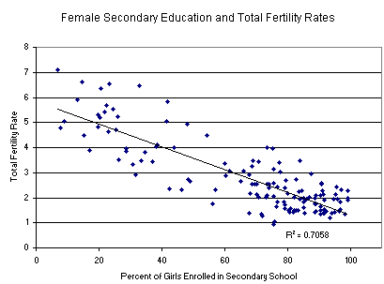
- Consider the graph on the right and explain what can be inferred from the data it presents.

- The first National Park was ________________ National Park.
- Match the ten most populous urban areas in the world with its respective continent:
Tokyo
Seoul
  - Asia Mexico City
  - N. America New York City
  - S. America Mumbai
  - Africa Jakarta
  - Australia Sao Paulo
  - Europe Delhi
Osaka/Kobe
Shanghai
- List three sources of methane that are amplified by human activities.
1)
2)
3)
- The box to the right contains a crude depiction of a mountain, use it to sketch and label the essential atributes of a rain shadow. Include labels for the direction of the prevailing winds and nearest ocean.
- NO₂ is converted to N₂ and O₂ in a _____________ _____________, which also converts _____ to _____.
- List causes of an urban heat island.
1)
2)
3)
- Identify the characteristic process associated with each of the following.
Nitrification:
Denitrification:
Assimilation:
Nitrogen Fixation:
Ammonification:
- CFC stands for _______________________________________,which are:

- Define the following…
Watershed:
Clean Air Act:
Clean Water Act:
Clean Drinking Water Act:
El Niño:
Baghouse filter
Electrostatic precipitator:
Dioxin:

